Lab # 13 & 14

Control Home Appliances using MIT App and Google Firebase Real-time Database

## Objectives

* Connect DH11 Humidity/Temperature Sensor to Local Server
* Use Smart Config to configure anonymous ESP32 with local Wifi
* Real time database creation using Google Firebase
* Connectivity of database with Android App and ESP32 Module
* Control of home appliances using ESP32

**Tools**

* Arduino
* ESP32 Board
* 2 LEDs
* DHT11 sensor
* Relay board
* 220V AC Light

**Pre Lab**

Please go through the data sheet of Expressif ESP32 development board.

**Task 1:**

**Temperature/Humidity Sensor Read using DHT Sensor:**

Step 1: Installing the DHT Library for ESP8266

1. Open your Arduino IDE and go to **Sketch** > **Include Library** > **Manage Libraries**. The Library Manager should open.
2. Search for “**DHT**” on the Search box and install the DHT library from Adafruit.

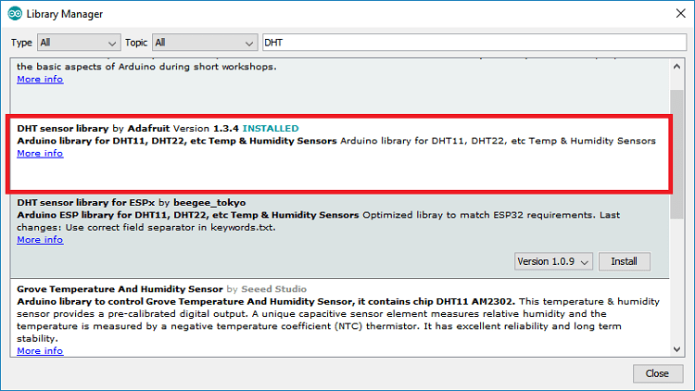

1. After installing the DHT library from Adafruit, type “**Adafruit Unified Sensor**” in the search box. Scroll all the way down to find the library and install it.

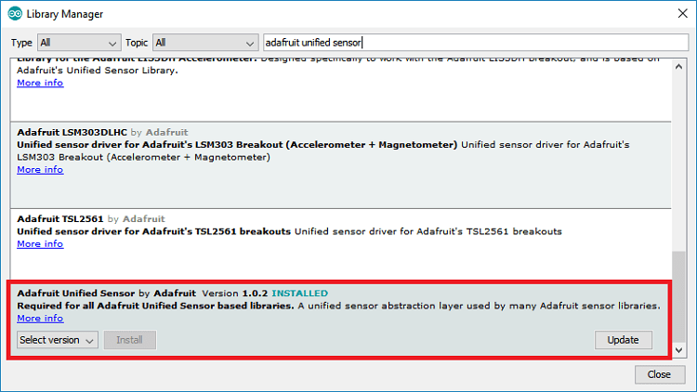

After installing the libraries, restart your Arduino IDE.

Step 2: Copy and Paste following Code

Example Code:

#include <WiFi.h> #include <WebServer.h> #include "DHT.h"

// Uncomment one of the lines below for whatever DHT sensor type you're using!

#define DHTTYPE DHT11 // DHT 11

//#define DHTTYPE DHT21 // DHT 21 (AM2301)

//#define DHTTYPE DHT22 // DHT 22 (AM2302), AM2321

/*Put your SSID & Password*/

const char* ssid = "Ahsan"; // Enter SSID here

const char* password = "12345678"; //Enter Password here

WebServer server(80);

// DHT Sensor uint8_t DHTPin = 15;

// Initialize DHT sensor. DHT dht(DHTPin, DHTTYPE);

float Temperature; float Humidity;

void setup() { Serial.begin(115200); delay(100);

pinMode(DHTPin, INPUT);

dht.begin();

Serial.println("Connecting to "); Serial.println(ssid);

//connect to your local wi-fi network WiFi.begin(ssid, password);

//check wi-fi is connected to wi-fi network while (WiFi.status() != WL_CONNECTED) { delay(1000);

Serial.print(".");

}

Serial.println(""); Serial.println("WiFi connected..!");

Serial.print("Got IP: "); Serial.println(WiFi.localIP());

server.on("/", handle_OnConnect); server.onNotFound(handle_NotFound);

server.begin();

Serial.println("HTTP server started");

}

void loop() { server.handleClient();

}

void handle_OnConnect() {

Temperature = dht.readTemperature(); // Gets the values of the temperature

Humidity = dht.readHumidity(); // Gets the values of the humidity

server.send(200, "text/html", SendHTML(Temperature,Humidity));

}

void handle_NotFound(){

server.send(404, "text/plain", "Not found");

}

String SendHTML(float Temperaturestat,float Humiditystat){ String ptr = "<!DOCTYPE html> <html>\n";

ptr +="<head><meta name=\"viewport\" content=\"width=device-width, initial-scale=1.0, user-scalable=no\">\n";

ptr +="<title>ESP32 Weather Report</title>\n";

ptr +="<style>html { font-family: Helvetica; display: inline-block; margin: 0px auto; text-align: center;}\n";

ptr +="body{margin-top: 50px;} h1 {color: #444444;margin: 50px auto 30px;}\n";

ptr +="p {font-size: 24px;color: #444444;margin-bottom: 10px;}\n"; ptr +="</style>\n";

ptr +="</head>\n"; ptr +="<body>\n";

ptr +="<div id=\"webpage\">\n";

ptr +="<h1>ESP32 Weather Report</h1>\n";

ptr +="<p>Temperature: "; ptr +=(int)Temperaturestat; ptr +="°C</p>";

ptr +="<p>Humidity: "; ptr +=(int)Humiditystat; ptr +="%</p>";

ptr +="</div>\n"; ptr +="</body>\n"; ptr +="</html>\n"; return ptr;

}

Step 3 : Select Proper Board

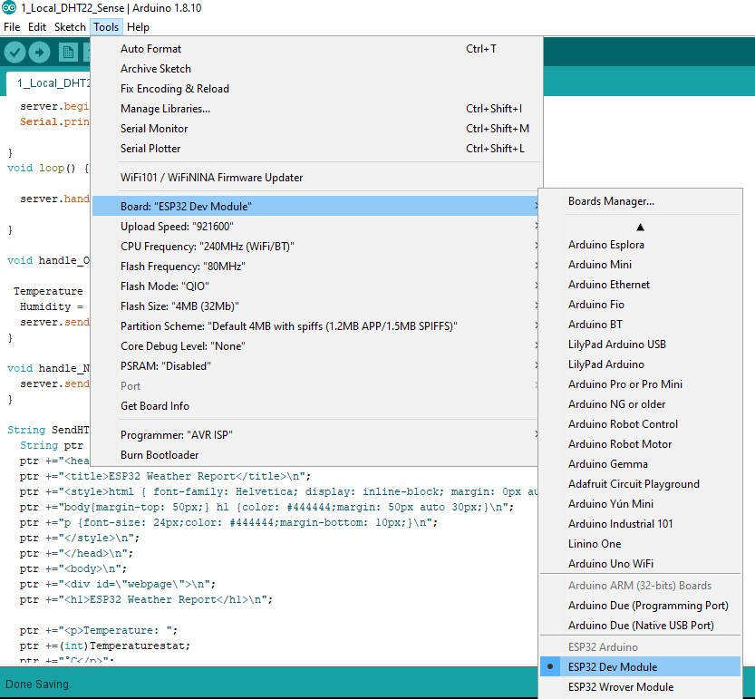

Step 4: Compile and Run the Program Output File:

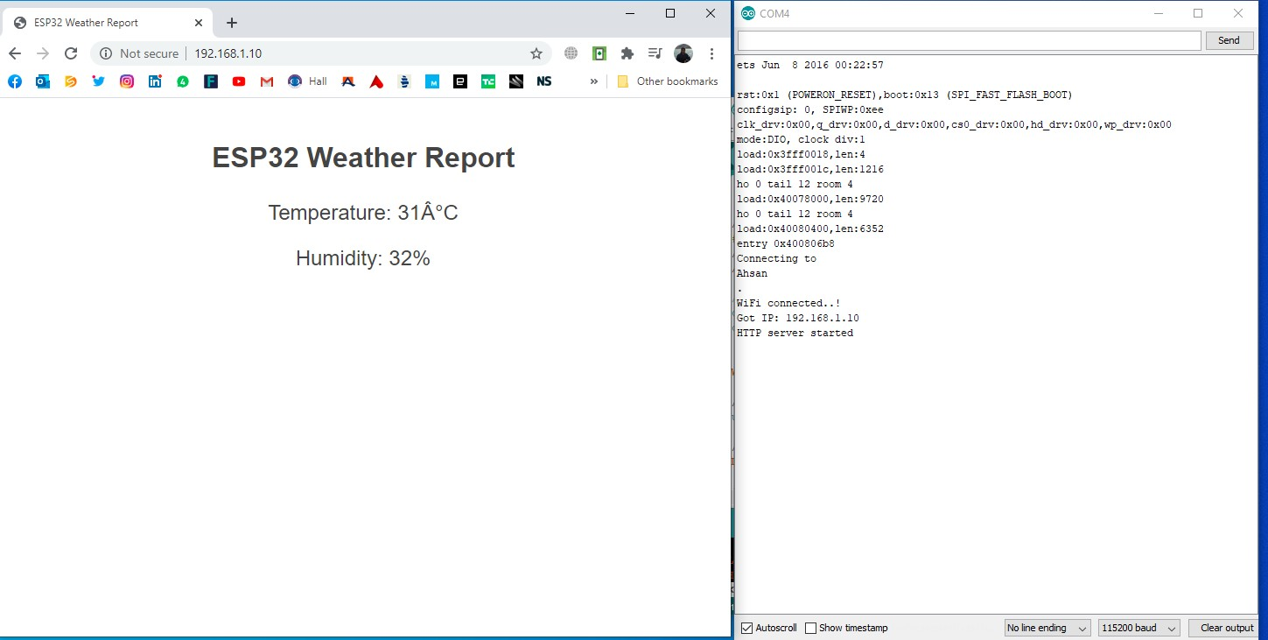

Task 2:

# Use ESP8266 Smart Config App from Google Playstore to allocate IP to ESP32 by your mobile at Run-time

Step 1: Install the App from Play store

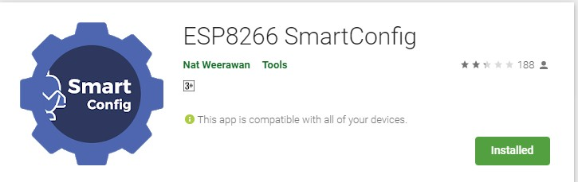

Step 2: Use the following program and burn it in ESP32

#include <WiFi.h> #include <WebServer.h>

// Use ESP8266 Smart Config App from playstore to allocate ip to ESP32 by your mobile,

// Use Wifi SSID and Pwd, which will assign IP to ESP 32

// No need to define Password and SSID within your code.

WebServer server(80);

uint8_t LED1pin = 4; bool LED1status = LOW;

uint8_t LED2pin = 5; bool LED2status = LOW;

void setup() { Serial.begin(115200);

/////////////////////////////////////////////

//Serial.begin(115200);

//Init WiFi as Station, start SmartConfig

WiFi.mode(WIFI_AP_STA); WiFi.beginSmartConfig();

//Wait for SmartConfig packet from mobile Serial.println("Waiting for SmartConfig."); while (!WiFi.smartConfigDone()) { delay(500);

Serial.print(".");

}

Serial.println(""); Serial.println("SmartConfig received.");

//Wait for WiFi to connect to AP Serial.println("Waiting for WiFi");

while (WiFi.status() != WL_CONNECTED) { delay(500);

Serial.print(".");

}

Serial.println("WiFi Connected.");

Serial.print("IP Address: "); Serial.println(WiFi.localIP());

/////////////////////////////////////////////// pinMode(LED1pin, OUTPUT); pinMode(LED2pin, OUTPUT);

//WiFi.softAP(ssid, password);

//WiFi.softAPConfig(local_ip, gateway, subnet);

delay(100);

server.on("/", handle_OnConnect); server.on("/led1on", handle_led1on); server.on("/led1off", handle_led1off); server.on("/led2on", handle_led2on); server.on("/led2off", handle_led2off); server.onNotFound(handle_NotFound);

server.begin();

Serial.println("HTTP server started");

}

void loop() { server.handleClient(); if(LED1status)

{digitalWrite(LED1pin, HIGH);} else

{digitalWrite(LED1pin, LOW);}

if(LED2status)

{digitalWrite(LED2pin, HIGH);} else

{digitalWrite(LED2pin, LOW);}

}

void handle_OnConnect() { LED1status = LOW; LED2status = LOW;

Serial.println("GPIO4 Status: OFF | GPIO5 Status: OFF"); server.send(200, "text/html", SendHTML(LED1status,LED2status));

}

void handle_led1on() { LED1status = HIGH;

Serial.println("GPIO4 Status: ON");

server.send(200, "text/html", SendHTML(true,LED2status));

}

void handle_led1off() { LED1status = LOW;

Serial.println("GPIO4 Status: OFF");

server.send(200, "text/html", SendHTML(false,LED2status));

}

void handle_led2on() { LED2status = HIGH;

Serial.println("GPIO5 Status: ON");

server.send(200, "text/html", SendHTML(LED1status,true));

}

void handle_led2off() { LED2status = LOW;

Serial.println("GPIO5 Status: OFF");

server.send(200, "text/html", SendHTML(LED1status,false));

}

void handle_NotFound(){

server.send(404, "text/plain", "Not found");

}

String SendHTML(uint8_t led1stat,uint8_t led2stat){ String ptr = "<!DOCTYPE html> <html>\n";

ptr +="<head><meta name=\"viewport\" content=\"width=device-width, initial-scale=1.0, user-scalable=no\">\n";

ptr +="<title>LED Control</title>\n";

ptr +="<style>html { font-family: Helvetica; display: inline-block; margin: 0px auto; text-align: center;}\n";

ptr +="body{margin-top: 50px;} h1 {color: #444444;margin: 50px auto 30px;} h3 {color: #444444;margin-bottom: 50px;}\n";

ptr +=".button {display: block;width: 80px;background-color: #3498db;border: none;color: white;padding: 13px 30px;text-decoration: none;font-size: 25px;margin: 0px auto 35px;cursor: pointer;border-radius: 4px;}\n";

ptr +=".button-on {background-color: #3498db;}\n";

ptr +=".button-on:active {background-color: #2980b9;}\n"; ptr +=".button-off {background-color: #34495e;}\n";

ptr +=".button-off:active {background-color: #2c3e50;}\n";

ptr +="p {font-size: 14px;color: #888;margin-bottom: 10px;}\n"; ptr +="</style>\n";

ptr +="</head>\n"; ptr +="<body>\n";

ptr +="<h1>ESP32 Web Server</h1>\n";

ptr +="<h3>Using Access Point(AP) Mode</h3>\n";

if(led1stat)

{ptr +="<p>LED1 Status: ON</p><a class=\"button button-off\" href=\"/led1off\">OFF</a>\n";} else

{ptr +="<p>LED1 Status: OFF</p><a class=\"button button-on\" href=\"/led1on\">ON</a>\n";}

if(led2stat)

{ptr +="<p>LED2 Status: ON</p><a class=\"button button-off\" href=\"/led2off\">OFF</a>\n";} else

{ptr +="<p>LED2 Status: OFF</p><a class=\"button button-on\" href=\"/led2on\">ON</a>\n";}

ptr +="</body>\n"; ptr +="</html>\n"; return ptr;

}

# Step 3: Open App and Enter Password against your Wifi Connection and enter CONFIRM

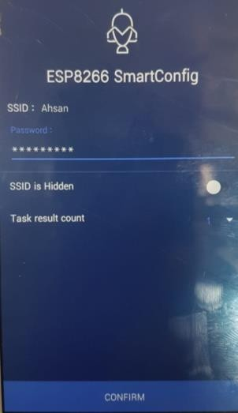

Step 4: Check Arduino Serial Output, it will show the Assigned IP from Wifi

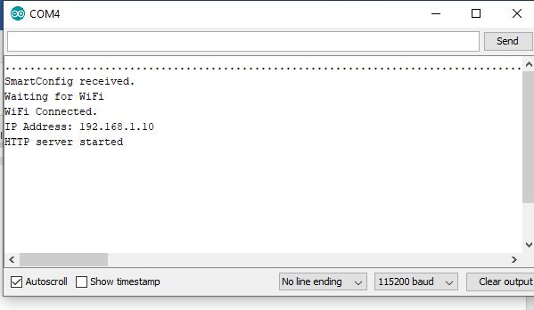

Step 5: Enter the IP into your Web Browser and control the output LEDs conneted

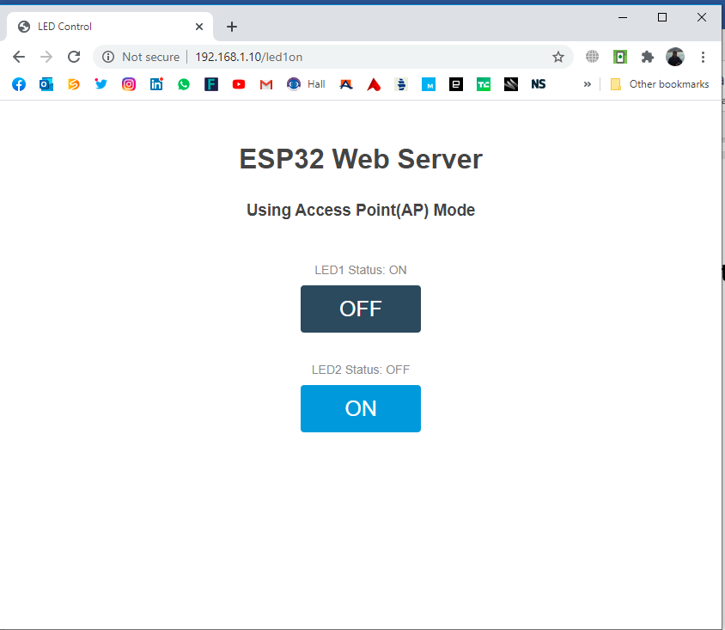

Step 6: Check your Hardware

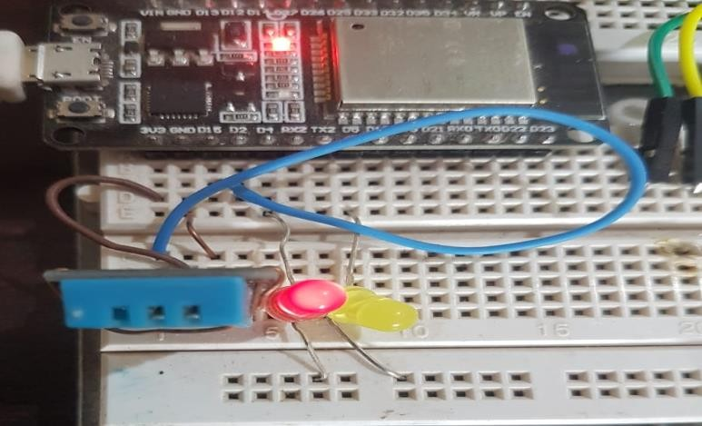

**Task 3: LED control using Google Firebase and ESP32**

**Step 1: Setting up Firebase Console for ESP32**

### If you are using firebase for the first time then you have to create account for firebase or can directly signup using Google Account:

* 1. Open your browser and go for [https://firebase.google.com](https://firebase.google.com/)
  2. At the right top corner click on **“Go to Console”.**

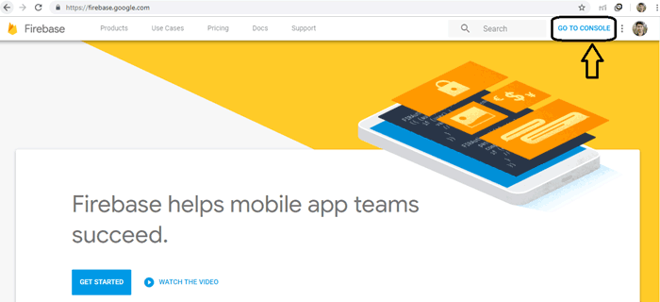

* 1. Click on “**Add Project**”.

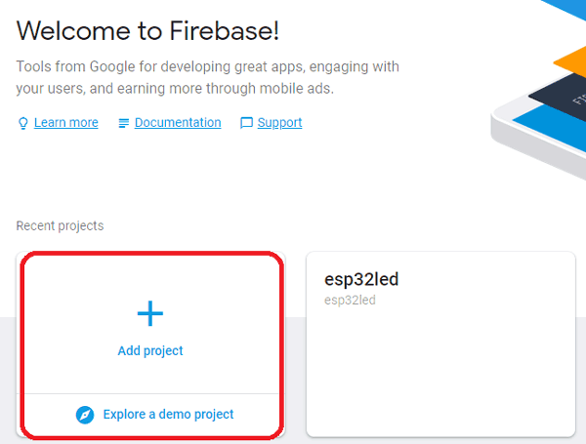

### Input your project name as you want and click on create project.

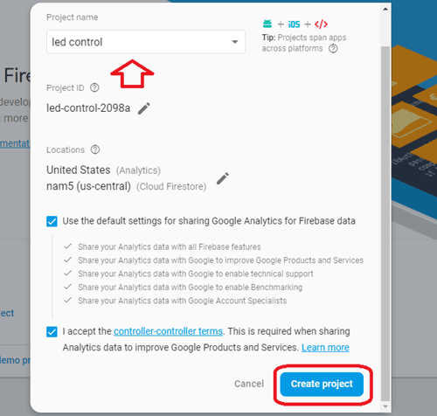

* 1. Now your project is created and click on “**Continue**”.

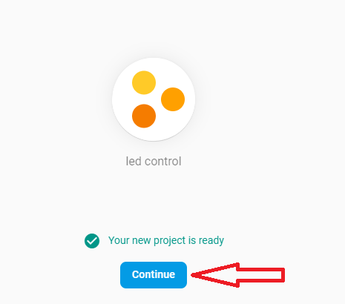

* 1. Now you will need host name and authorization key/secret key for this project while programming your ESP32; so now we will see how these parameters can be taken from this.
  2. Go to setting icon and click on “**Project Setting**”.

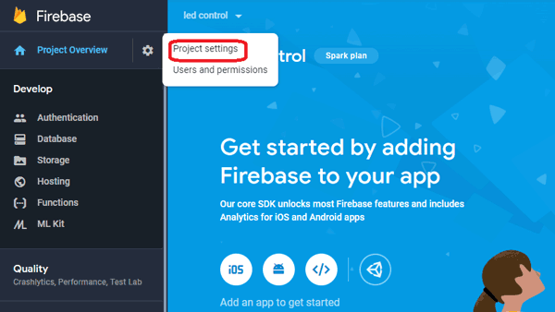

* 1. Now click on **Service accounts** and then **Database secrets**.

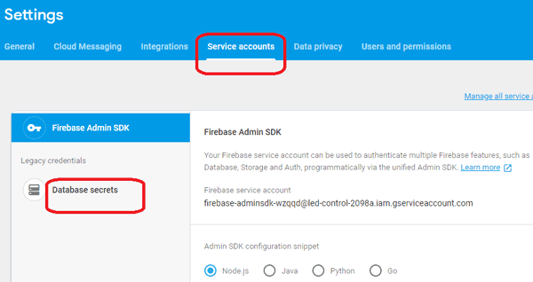

### On clicking on *Database Secrets* you will find a secret key, copy this key and save it in notepad, this is your firebase authorization key which you will need later.

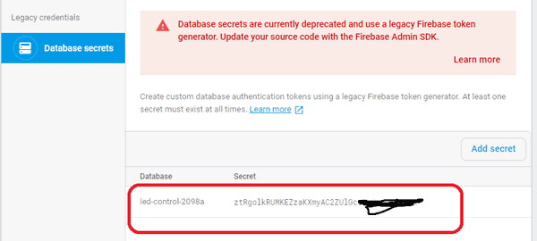

* 1. Now click on “**Database**” at left control bar.

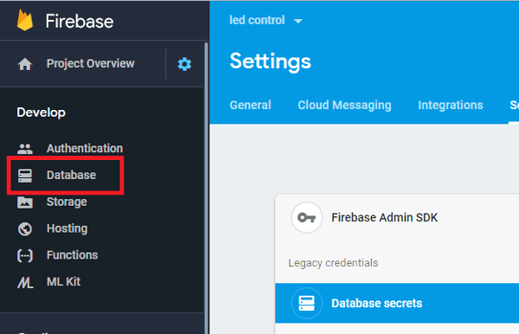

* 1. Now scroll down and click on **“Create database”.**

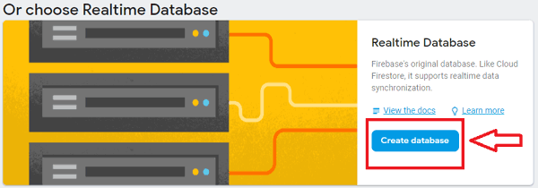

* 1. Now choose “**Start in test mode**” and click on **Enable**.

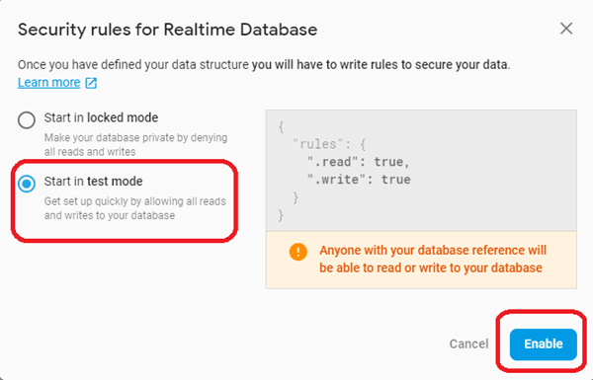

### Now your database is created and you will have to come here again to control your LED, for now just copy the given URL without slash and http in notepad this is your **firebase host** which you will be required later.

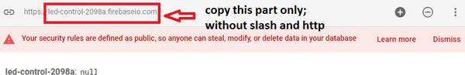

**Step: Setting up ESP32 module with Firebase**

To work with **ESP32 using Google firebase** you will need a firebase library so firstly download that library using below link and save it in Arduino library files.

<https://github.com/ioxhop/IOXhop_FirebaseESP32>

Now open your Arduino IDE and go to *Sketch---> include Library--> Add .ZIP library* and add the file you downloaded from the above link.

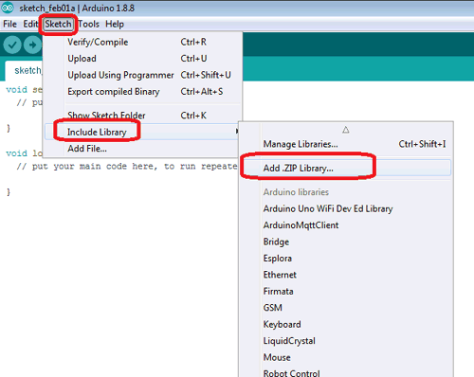

### After installing the library you are ready to work with Google firebase using ESP32.

Now go to Tools and select ESP32 Dev board and appropriate COM port and copy the code given below and edit it for network credentials, firebase secret key and firebase host. After editing the upload the code into ESP32 using Arduino IDE.

**Step 3: Programming ESP32 for Google Firebase**

**Complete code for controlling LED using ESP32** is given at the end of the tutorial Firstly include the libraries for using ESP32 and firebase.

**#include <WiFi.h>**

**#include <IOXhop_FirebaseESP32.h>**

### Now enter your firebase host, secret key and network credentials.

**#define FIREBASE_HOST "esp32led.firebaseio.com"**

**#define FIREBASE_AUTH "4QHdeFZquTh4fdXZkum2EPt2A50gXXXXXXXXX" #define WIFI_SSID "XXXXXX"**

**#define WIFI_PASSWORD "XXXXXXXXXX"**

In the *setup* function, define output pin, delay, baud rate and connect to your Wi-Fi.

**void setup() { Serial.begin(9600); delay(1000); pinMode(2, OUTPUT);**

**WiFi.begin(WIFI_SSID, WIFI_PASSWORD);**

**Serial.print("Connecting to "); Serial.print(WIFI_SSID);**

**while (WiFi.status() != WL_CONNECTED) { Serial.print(".");**

**delay(500);**

**}**

The below statement tries to connect with the firebase server. If the host address and authorization key are correct then it will connect successfully.

Firebase.begin(FIREBASE_HOST, FIREBASE_AUTH);

Now this is the class provided by firebase library to send string to firebase server. With the help of this we can change the status of LED.

**Firebase.setString("LED_STATUS", "OFF");**

After sending one status string to firebase path, write this statement to get the status of LED from same path and save it to variable.

**fireStatus = Firebase.getString("LED_STATUS");**

If received string is “ON” or “on” then just turn on the output LED.

**if (fireStatus == "ON")**

**{**

**Serial.println("Led Turned ON"); digitalWrite(2, HIGH);**

**}**

If received string is “OFF” or “off” then just turn off the output LED.

**else if (fireStatus == "OFF") { Serial.println("Led Turned OFF"); digitalWrite(2, LOW);**

**}**

If received string is not any of these then just ignore and print some error message.

**else {**

**Serial.println("Wrong Credential! Please send ON/OFF");**

**}**

The complete code is given at the end of this article, you can check from there, edit it and then upload it.

**Step 4: Check your Output**

### After uploading the code open your serial monitor and in your browser open firebase and go to console and then select your project that you created earlier. In this go to database and it will show initially LED STATUS is OFF, from here you can change the LED status by writing ON here, your LED will change to ON state and you can see your LED state in your serial monitor also.

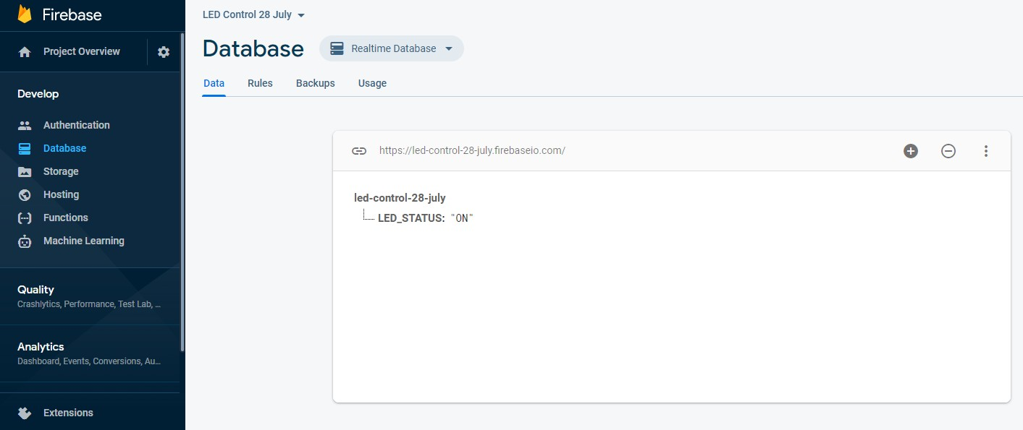

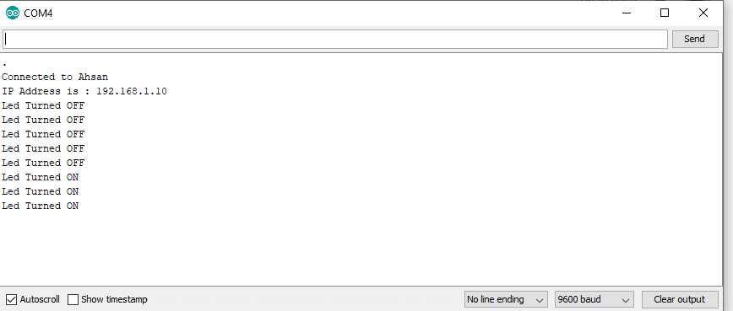

**Step 5: Code**

#include <WiFi.h>

// esp32 library

#include <IOXhop_FirebaseESP32.h>

// firebase library

#define FIREBASE_HOST "led-control-28-july.firebaseio.com/"

//firebase id

// the project name address from

#define FIREBASE_AUTH "J6X1bbwAWGmmIxChCRnygFlJw6ReW63GGEK44K1g"

//key generated from firebase

// the secret

#define WIFI_SSID "Ahsan"

// input your home or public wifi name

#define WIFI_PASSWORD "12345678"

//password of wifi ssid

String fireStatus = "";

// led status received from firebase

int led = 4;

void setup() {

Serial.begin(9600);

delay(1000);

pinMode(4, OUTPUT);

WiFi.begin(WIFI_SSID, WIFI_PASSWORD); //try to connect with wifi

Serial.print("Connecting to ");

Serial.print(WIFI_SSID);

while (WiFi.status() != WL_CONNECTED) {

Serial.print(".");

delay(500);

}

Serial.println();

Serial.print("Connected to ");

Serial.println(WIFI_SSID);

Serial.print("IP Address is : ");

Serial.println(WiFi.localIP()); //print local IP address

Firebase.begin(FIREBASE_HOST, FIREBASE_AUTH); // connect to firebase

Firebase.setString("LED_STATUS", "OFF");

//send initial string of led status

}

void loop() {

fireStatus = Firebase.getString("LED_STATUS");

// get led status input from firebase

if (fireStatus == "ON") {

// compare the input of led status received from firebase

Serial.println("Led Turned ON");

digitalWrite(4, HIGH);

// make output led ON

}

else if (fireStatus == "OFF") {

// compare the input of led status received from firebase

Serial.println("Led Turned OFF");

digitalWrite(4, LOW);

// make output led OFF

}

else {

Serial.println("Wrong Credential! Please send ON/OFF");

}

}

**Step 6: Hardware Demo**

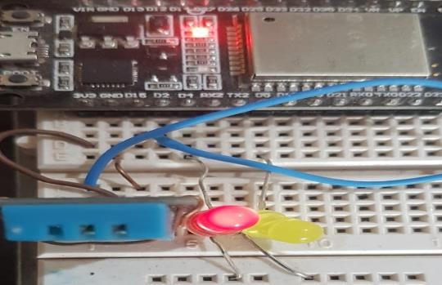

**Task 4: LED control using Google Firebase, ESP32 and Mobile App**

**Step 1: Create App on MIT App Inventor Goto link:** <http://ai2.appinventor.mit.edu/>

* + 1. **Create your account.**
    2. 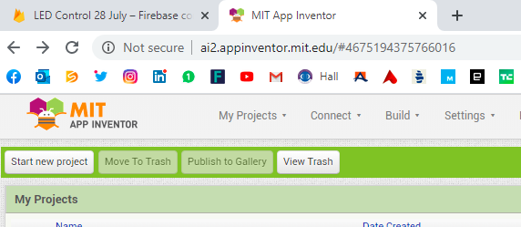**After Login start new project:**
    3. **Following screen appears**

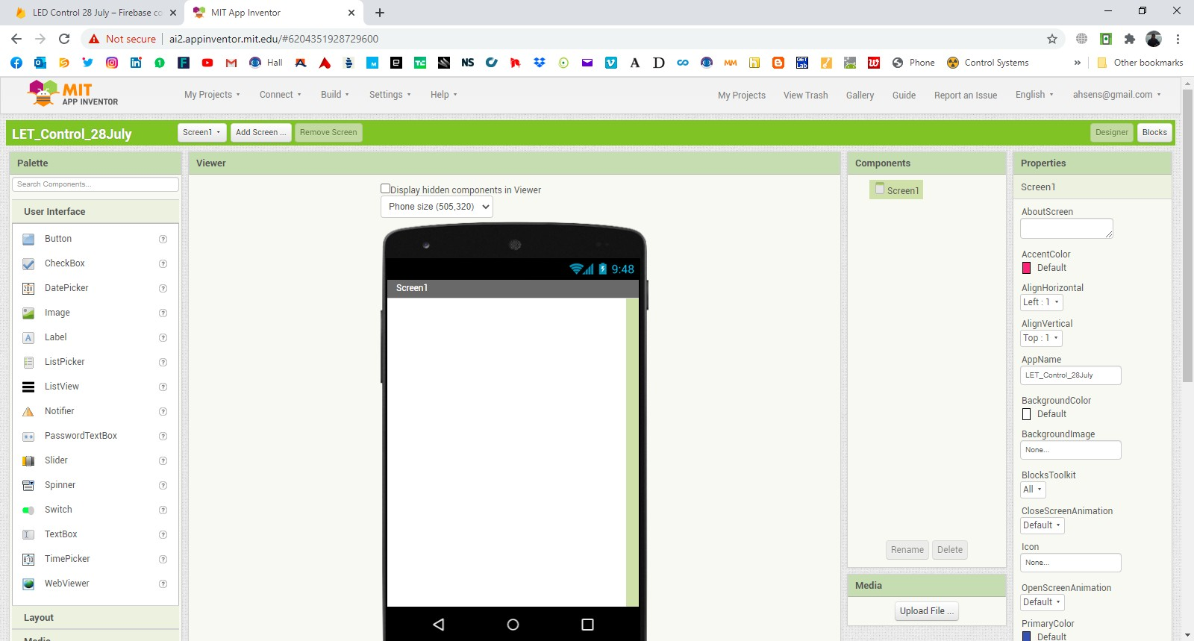

* + 1. **Drag and drop four buttons and one firebase link as follows:**

Project Bucket on right side must be empty.

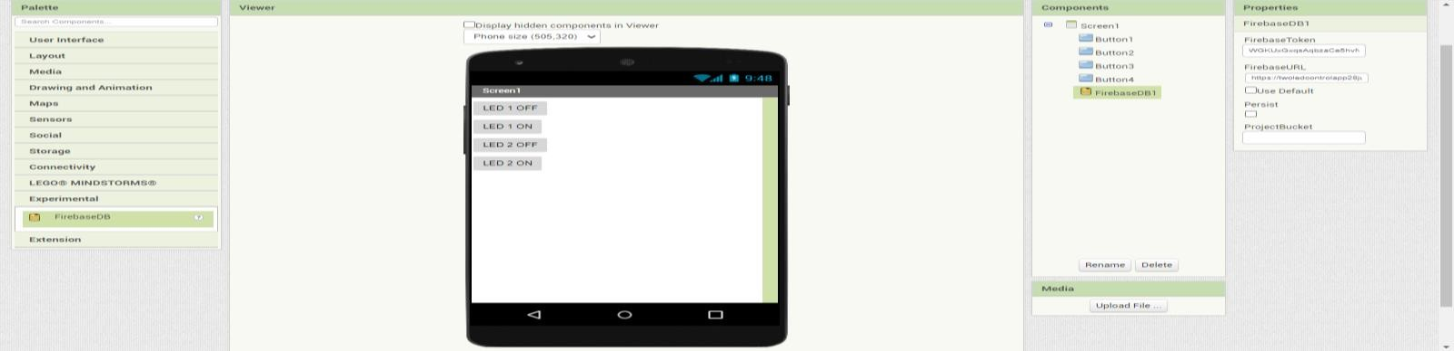

**5: Enter firebase database link in Firebase URL and database secret key in in Firebase token**

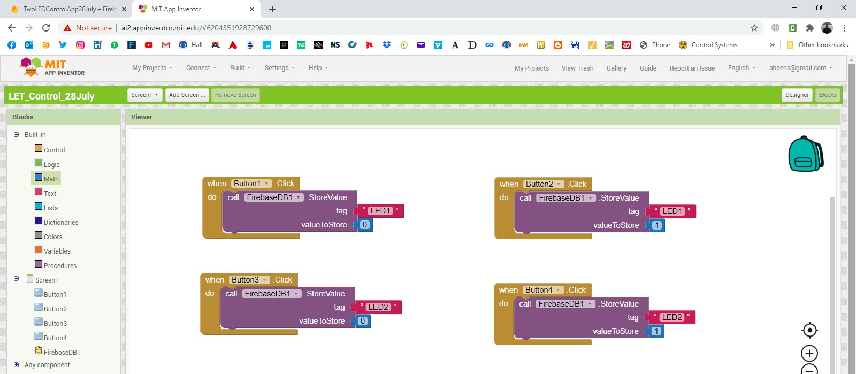**6: Goto Blocks and do following**

**7: Use Build to generate .apk file for your mobile and install this in your android mobile.**

## Or install MIT AI2 Companion app in your mobile and use Connect to see and simulate app in real time using your mobile.

**Step 2: Create real-time database using steps mentioned in task above. Step 3: Use following code and burn inside your ESP32 Controller.**

#include <WiFi.h> // esp32 library

#include <IOXhop_FirebaseESP32.h> // firebase library #define FIREBASE_HOST "twoledcontrolapp28july.firebaseio.com/" //Your Firebase //Project URL goes here without "http:" , "\" and "/"

#define FIREBASE_AUTH "WGKUxGxqsAqbzaCe5hvNG9qC8gSekvvTLmFVFQPe"

//Your Firebase Database Secret goes here

#define WIFI_SSID "Ahsan" //your WiFi SSID for which yout NodeMCU connects

#define WIFI_PASSWORD "12345678" //Password of your wifi network String fireStatus = ""; // led status received from firebase String fireStatus2 = "";

const int led1 = 4; const int led2=5;

void setup() { Serial.begin(9600); delay(1000);

pinMode(4, OUTPUT); pinMode(5, OUTPUT);

WiFi.begin(WIFI_SSID, WIFI_PASSWORD); //try to connect with wifi

Serial.print("Connecting to "); Serial.print(WIFI_SSID);

while (WiFi.status() != WL_CONNECTED) { Serial.print(".");

delay(500);

}

Serial.println(); Serial.print("Connected to ");

Serial.println(WIFI_SSID); Serial.print("IP Address is : ");

Serial.println(WiFi.localIP()); //print local IP address

Firebase.begin(FIREBASE_HOST, FIREBASE_AUTH); // connect to firebase

Firebase.setString("LED1", "0"); //send initial string of led status Firebase.setString("LED2", "0");

}

void loop() {

fireStatus = Firebase.getString("LED1"); // get led status input from firebase

if (fireStatus == "1") { // compare the input of led status received from firebase

Serial.println("Led1 Turned ON");

digitalWrite(4, HIGH); // make output led ON

}

else if (fireStatus == "0") { // compare the input of led status received from firebase

Serial.println("Led1 Turned OFF");

digitalWrite(4, LOW); // make output led OFF

}

else {

Serial.println("Wrong Credential for LED1! Please send ON/OFF");

}

fireStatus2 = Firebase.getString("LED2");

if (fireStatus2 == "1") { // compare the input of led status received from firebase

Serial.println("Led2 Turned ON");

digitalWrite(5, HIGH); // make output led ON

}

else if (fireStatus2 == "0") { // compare the input of led status received from firebase

Serial.println("Led2 Turned OFF");

digitalWrite(5, LOW); // make output led OFF

}

else {

Serial.println("Wrong Credential for LED2! Please send ON/OFF");

}

}

**Step 4: Control the LEDs using your Mobile App in real time.**

**Task 5: Control of Home appliances using MIT App and Firebase using ESP 32 Simple relay circuit to switch ON/OFF Bulb**

**Output:**

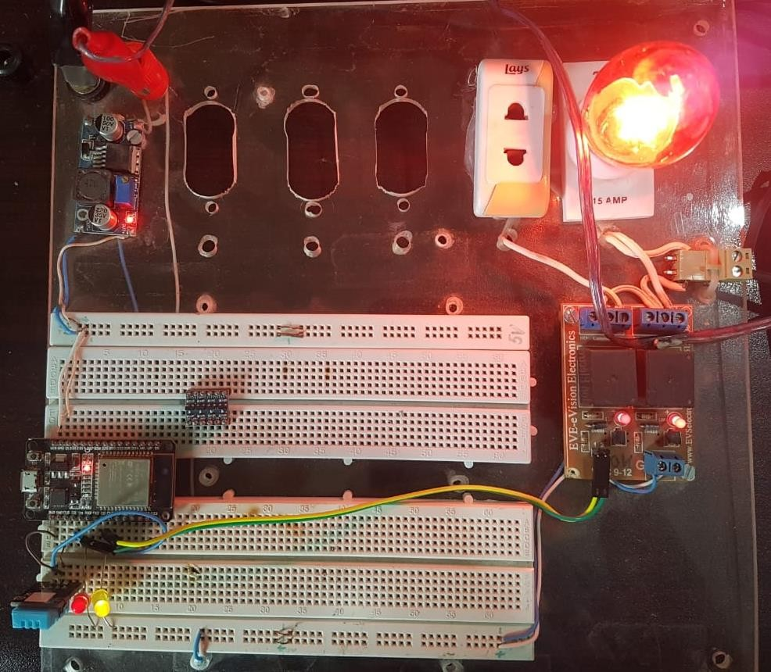

**Post-Lab Task :**

**Critical Analysis / Conclusion**

(By Student about Learning from the Lab)

|  |  |  |  |  |
| --- | --- | --- | --- | --- |
| **Lab Assessment** | | | | |
| **Pre Lab** | | | **/1** | **/10** |
| **In Lab** | | | **/5** |
| **Post Lab** | **Data Analysis** | **/4** | **/4** |
| **Data Presentation** | **/4** |
| **Writing Style** | **/4** |
| **Instructor Signature and Comments** | | | | |